B.W.J.N. Bandara

EU/IS/2019/PHY/76

PS2826

**TASK 2**

In this implementation, a structured IP addressing scheme was developed to efficiently allocate IP ranges to different network segments. Two primary VLANs were created:

* **VLAN 10 – Management**
* **VLAN 20 – Guest**
* VLAN 30 – Finance
* VLAN 40 – HR

Each VLAN was assigned its own subnet to logically separate traffic and enhance network security and performance. Basic IP configurations were applied to routers and switches to enable communication within and between VLANs.

Access layer switches were configured with appropriate VLAN assignments for each port based on user roles. Inter-VLAN routing was achieved using a router with sub-interfaces, allowing devices from different VLANs to communicate while maintaining segmentation.

IP Scheme

|  |  |  |  |  |
| --- | --- | --- | --- | --- |
| **VLAN Name** | **VLAN ID** | **Subnet** | **Gateway** | **Purpose** |
| Management | 10 | 192.168.1.0/24 | 192.168.1.254 | Admins/IT staff |
| Management | 10 | 192.168.3.0/24 | 192.168.3.254 | Admins/IT staff |
| Guest | 20 | 192.168.2.0/24 | 192.168.2.254 | Visitors/Students |
| Guest | 20 | 192.168.4.0/24 | 192.168.4.254 | Visitors/Students |
| Finance | 30 | 192.168.5.0/24 | 192.168.5.254 | Finance Department |
| HR | 40 | 192.168.6.0/24 | 192.168.6.254 | HR Department |

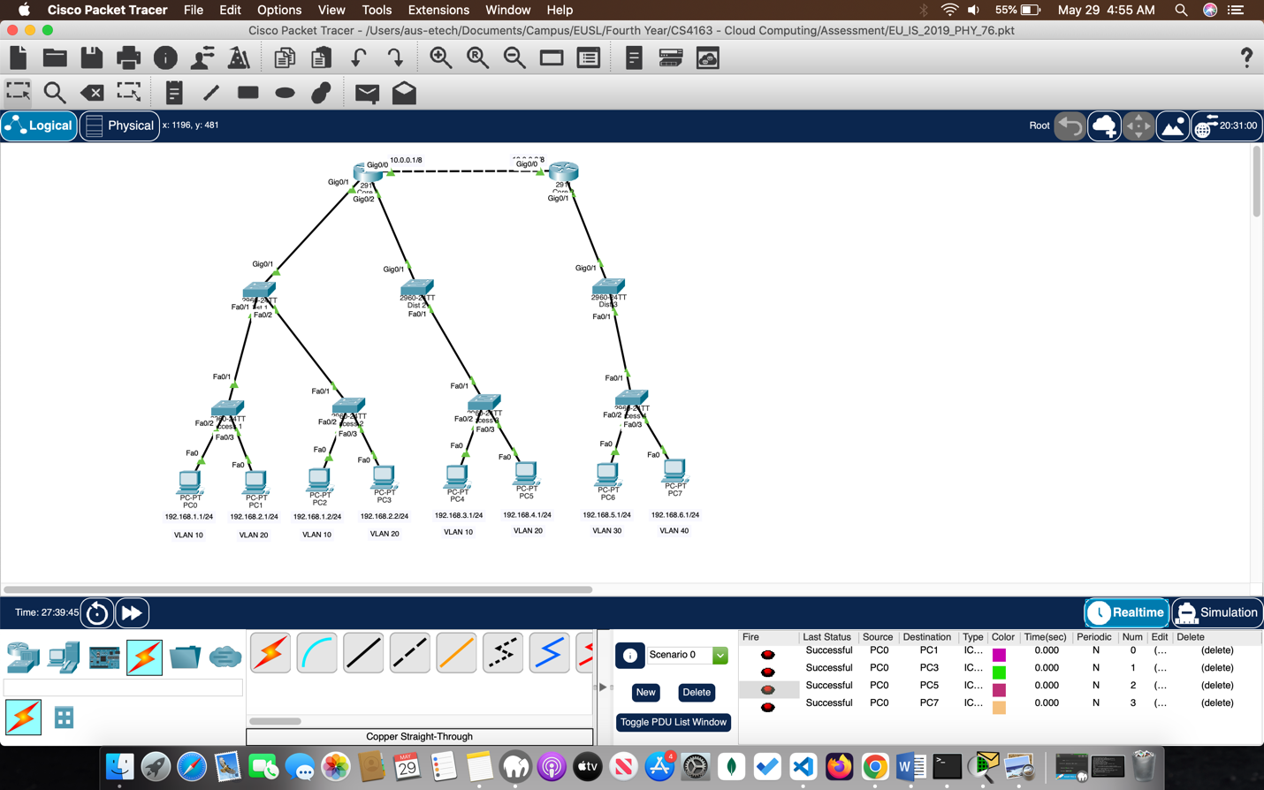

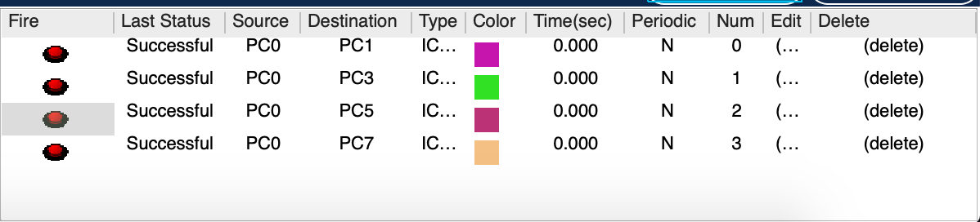

Access 1 – Switch Configuration

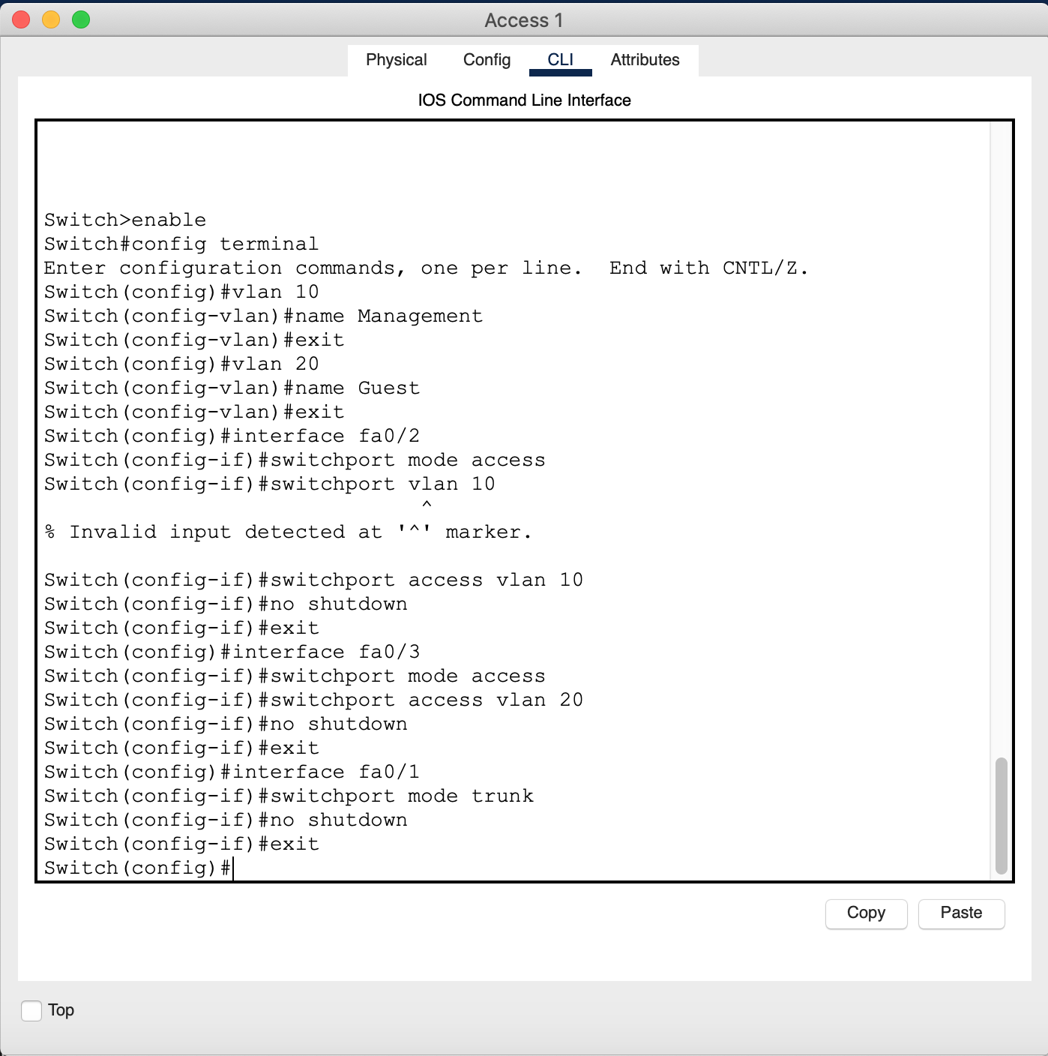

Dist 1 – Switch Configuration

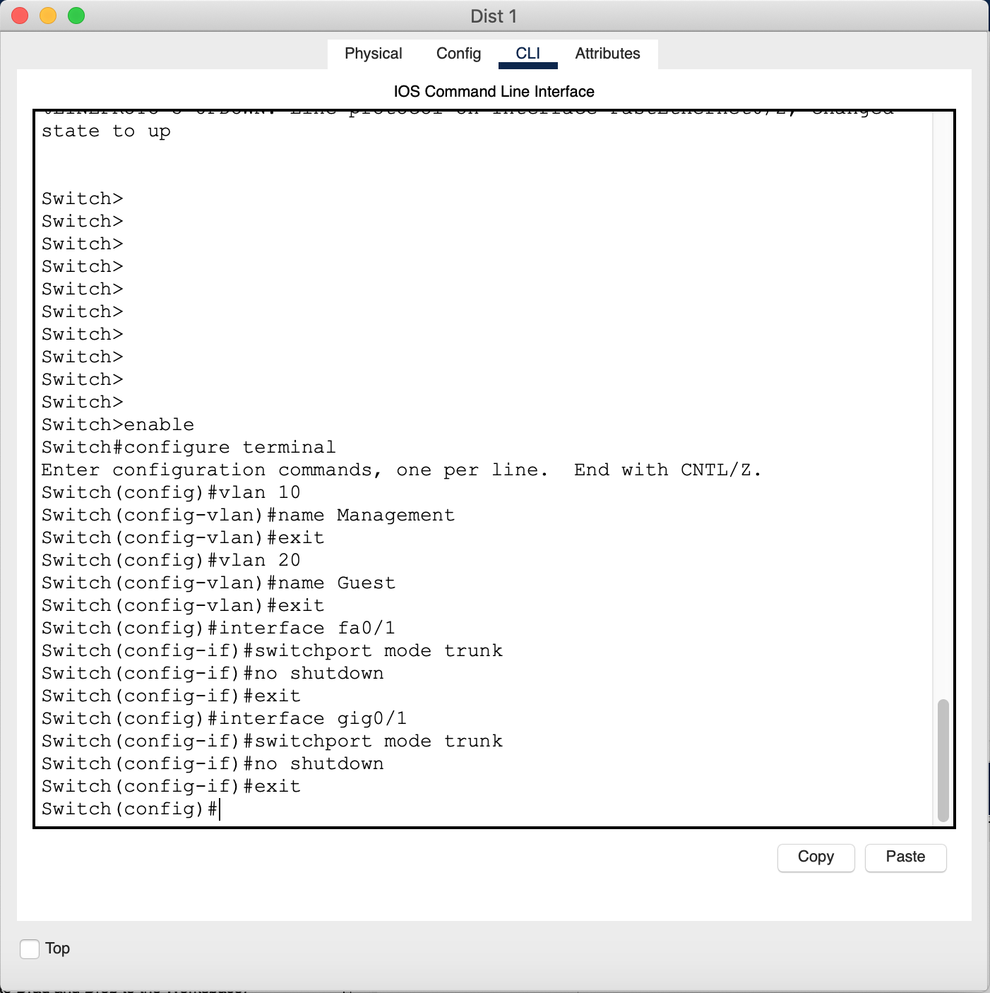

Core 1 – Router Configuration

